Social Sciences
Etoys City Map
Fourth – Fifth Grade Levels

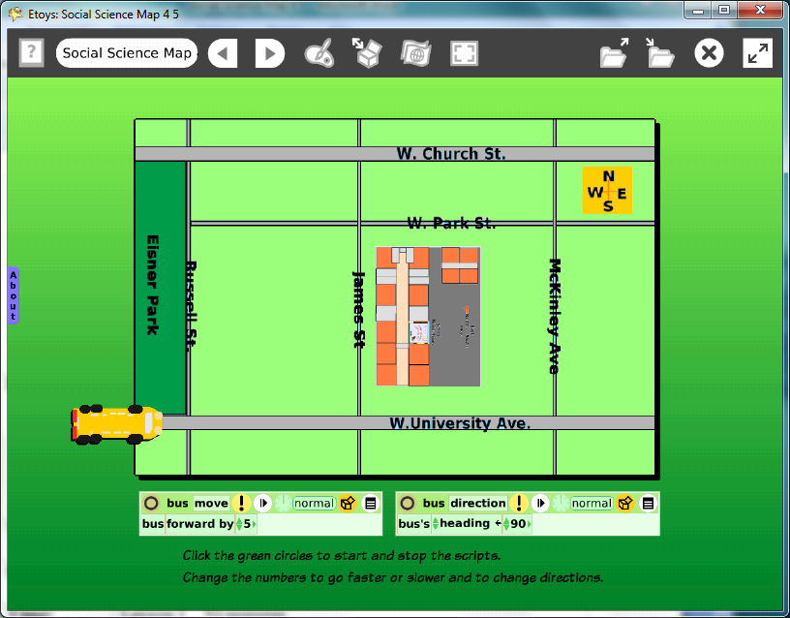

Introduction: | These Etoys project gives students practice observing a familiar area, analyzing shapes and distances, and then representing them on a map grid of streets near their school.  This city map is then used as a place where a virtual school bus moves to locations on the map.
Topic: | Creating maps of familiar places and navigating in them
Subject: | Social Sciences
Time: | Lesson 1 50 minutes  Lesson 2 30 minutes
Description: | This project gives students practice observing 3D objects such as buildings, playgrounds and streetscapes, and visualizing them as basic 2D shapes most probably, rectangles.  Students explore the limits of map making: Can we really show everything exactly when we make maps?
Vocabulary: | above, top, right, upper, center, on, up, beside, behind, below, bottom, left, lower, edge, near, down, before, between, larger, smaller, close, near, next to, far, almost, same, rectangle, curve, triangle, ellipse, bigger, smaller, almost, exactly, North, South, East, West, co-ordinate grid, heading, x-axis, horizontal line, y-axis, vertical line
Evaluation Criteria: | Recognizes that buildings, playgrounds and streets can be represented by 2D shapes on a map.  Shows the difference in proportions of the building and city.  Shows knowledge of the school’s location and nearby streets.  Uses a vocabulary of location fluently.  Knows the Cardinal directions and shows them on their map.  Uses headings of 0, 90, 180, and -90 to move on a map.  Moves an avatar (a drawing of a bus) to different locations on their map.
Teacher Information:  Etoys Quick Guides: Click the question mark in  Etoys to open the set of tutorials about basic tools and techniques. | Etoys Quick Guides: Click the question mark in  Etoys to open the set of tutorials about basic tools and techniques.  Use Etoys Quick Guides if the lesson mentions unfamiliar tools or techniques. Give students time to read them too.
Goals: | Students will create a map of the area surrounding their school building showing major streets and the Cardinal directions.  They will use headings to change the direction of a virtual bus on their map.  This project is based on a new map or one that uses the school building map they made in 2-3 grade level of the Technology Passport.
Lesson 1:  Two labs  Quick Guides  Navigator Bar: Keep Find Projects  Halo Handles:  Color, Size, Copy  Supplies: Text | Discuss: What are the names of nearby streets?  Are there any parks or businesses close to the school? What other landmarks are there? How many blocks to the nearest park, bus stop, store?  Make street maps.  Start the street map by having students open the building map from their 2-3 grade projects. If that is not available, then students need to make that map first or use one prepared for them.  Use the halo’s tool to change the size of the building map.  Put the building map in Supplies.  Start a new project and drag the building map from Supplies into the new project.  Build the rest of the city streets out of shapes from Supplies.  Students should modify the shapes with the copy color size tool in the halo of handles.  Label streets. Put the school map in its correct location in the street map.  Give students time to work.  Keep the project Publish As: namecitymapdate  For example: katecitymapjan07
Extend Lesson 1 | Discuss the maps students have created.  Let students look at other students’ maps and discuss them. Ask why they think there are differences between maps.  Give students time to make changes to their map. The computer makes the editing process easy, enjoyable, and valuable.  Keep the project again with the same name. A version number will be added to the project automatically.  For example: namecitymapjan07.01
Lesson 2:  Two labs  Object Catalog:  Grab Patch  Halo Handles: Rotate  Paint Tools  Halo Handles: Viewer  Script Tiles: Forward by  Script Tiles: Heading | This lesson modifies the city map made in Lesson 1 and uses it as a place to navigate. Students practice using the Cardinal directions, X and Y co-ordinates, and headings.  Have students open their city map.  Discuss whether all the maps they can see have the same orientation. Where is North on the map, on the screen?  Copy the city map using the Grab Patch tool.  The new copy will be more like a paper map in that the things on the map can’t be moved but the whole map can be turned.  Turn the map so north is at the top of the screen and then resize the map so it has a border about four fingers wide on all sides.  Ask students to draw a school bus using the paint tool. Click Keep in the paint palette when the drawing is done. Now they add scripts so the bus will move.  Change the name of the sketch in the Halo: click on the Sketch and type in a name for the bus, for example: Bus104.  The new name will be on every script tile in the Viewer for the bus.  Create a script to move the bus on the map.  Click the tile ‘Bus104 forward by 5’ drop it onto the screen.  Click the green clock to start and stop the script.  Make another script with the heading tile. Show students how to change the heading of the bus using script tiles using the heading tile in the Viewer.  Change the heading to 90. Click the exclamation point to run the script once. Start the ‘Bus104 forward by 5’ script. Discuss.  Experiment with the script’s number and ask students to tell you what they see happening. Did they try a negative number?  Publish this new project.  Call it namecitymap2012
Extend Lesson 2  Script Tiles:  Exact Location  Script Tiles: X and Y Tiles  Menus:  Scriptor Icons Set | 1. Use X and Y co-ordinates on the building map.  Look at the numbers in the Viewer that follow the tiles ‘Bus104’s X’ and Bus104’s Y.  Notice the values change when the bus moves on the map.  Move the bus to X = 300 Y = 400 on the school map.  Are all the buses at the same bus stop in the all maps? Why/why not?  Can we make the maps all the same size? Should we? What will be gained and what will be lost?  Experiment with the changing the size and the proportions.  Are the streets proportional to real streets and buildings?  When in this project should we have started measuring?  Experiment with other headings. Which headings keep the bus on the streets or, perhaps, parallel to them?  Create one headings script and experiment with: 0, 90, 180,-90 to steer the moving bus on the grid of streets. Are there streets that need other headings?  Leave the heading script on the green Normal setting.  Start the ‘Bus104 forward by 5’ script and then, to turn the bus, click on the new heading’s bright yellow oval to run a script one time. Change headings as the bus moves or stop the bus and change the heading if the turns happen too quickly.
Student Information: | The teacher leads with spoken directions or provides a print copy of the lesson. An LCD projector will help students visualize the project.
Standards: | State of Illinois Assessment Framework: Social Sciences:  Fourth Grade:  17.5.03: Identify map features.  17.5.07: Locate places using cardinal directions.  Fifth Grade  17.5.03: Identify map features.  Illinois Performance Standards: Mathematics  Fourth Grade: To use letter-number pairs and ordered pairs of numbers to locate points on a rectangular grid and to use a map scale. 8B, 7C  Fifth Grade: Review coordinate grids 8A, 8B  National Educational Technology Standards  1. Basic operations and concepts  Students demonstrate a sound understanding of the nature and operation of technology systems.  Students are proficient in the use of technology.  3. Technology productivity tools  Students use technology tools to enhance learning, increase productivity, and promote creativity.  Students use productivity tools to collaborate in constructing technology-enhanced models, prepare publications, and produce other creative works.
Resources: | Etoys Help Quick Guides: Click the question mark in the Navigator Bar to open a set of interactive tutorials that introduce basic tools and techniques.  EtoysIllinois.org projects, tutorials and lesson plans  Squeakland.org download Etoys software
kh
April 8, 2012

